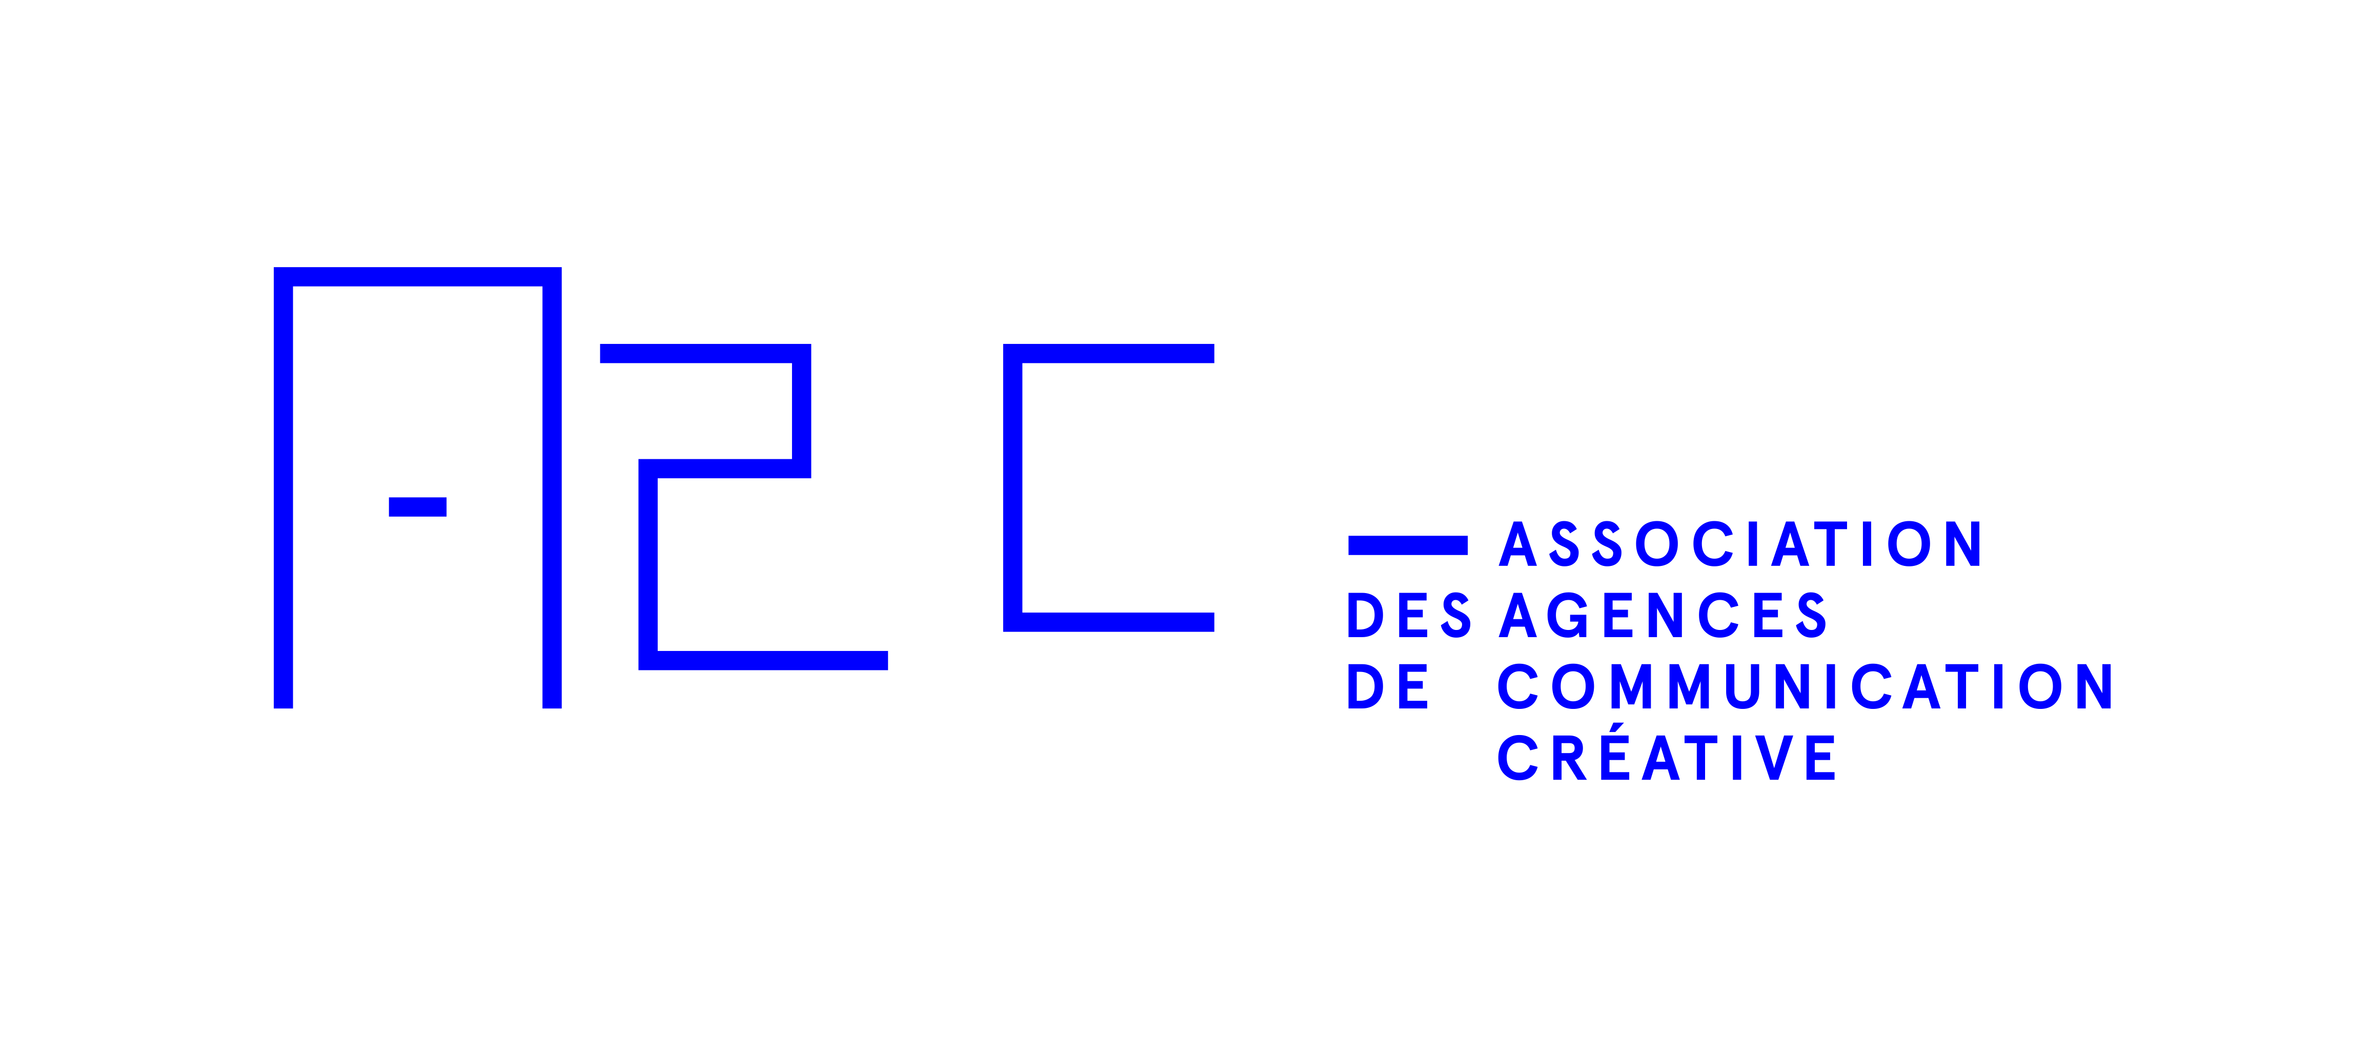

Request for proposals
Within the agency selection process
Organizations/private companies

Model you can fill out and adapt to your needs.

This document is a tool that can guide you when you draft your request for proposals. It relies on the principles outlined in the A2C’s Agency Selection Guide which you can find at https://a2c.quebec/en/how-to-choose-an-agency/toolbox.

It is important that the complexity of your request for proposals be proportional to the budget allocated to your mandate and its duration. In any case, you should keep your process as simple and efficient as possible.

For one-time projects, or for exhaustive projects with a budget between $200,000 and $450,000 (including media, production, and agency remuneration): the process should consist of an agency presentation that each organization prepares using their own criteria to showcase their skills that align with your mandate.

For mandates with a budget of over $450,000 or that is part of a medium or long-term service offer (ex.: 3 years of more), we suggest you schedule an initial exploratory meeting with 3 to 5 agencies to assess the chemistry between your organization and theirs. Select 3 finalist agencies who will prepare an agency presentation addressing your requirements as outlined in this request for proposal template.

We recommend you ask them to sign a non-disclosure agreement (NDA) to protect the confidential and strategic information contained in this document.

Types of services sought

You could search for an agency that specializes in one field or an agency with many skillsets under one roof. When drafting your request, please consult the Annex I for a few helpful precisions you might want to add in the description of your mandate, depending on the skills you are looking for.

Resources

Don’t hesitate to consult the Agency Selection Guide which contains exhaustive information on the topic or contact us for more information and free and confidential advice: i.poirier@a2c.quebec

Legend:
_ : Points you can write or modify depending on your needs.
• : Insert your text
_ and Italic text : General note (example or explanation) to be deleted from your final version.
• (Title of your request for proposals) / • (# of your request for proposals)

Person who will answer questions and collect the documentation

Example:

Send your questions to | Attn:  • (name), • (title) | By email: •  or  phone: •
Send your documents to | Attn:  • (name), • (title) | By email: •  or  mail/messenger/in person: •

Regarding • (name of your organization)

Examples of information to be provided by and on your organization
- Present a short description of your organization
- Describe your industry or sector and its main competitors, as well as the general context in which you operate.

Description of the mandate and services required

Examples of what to include to accurately describe your needs and expectations:

- Describe your business and marketing objectives.
Another way to convey your objectives is to describe the expected results. Here are a few examples of results that could coincide with your mandate:
  - Business results: amount of sales, market share, market penetration, full price Vs discounted sales, average sales price, profit margins, etc.
  - Marketing results: requests for information, number of potential consumers (leads), in-store traffic, search results ranking, number of page views on your website, customer frequency of purchase, number of new customers, press coverage, online mentions, etc.
  - Customer focused results: brand awareness, brand preference, intent to buy, level of brand appreciation, propensity to justify a high price, etc.
  - Results related to sales and distribution: average sales per representative, knowledge level of representatives, representatives recommendations, request for information by distribution channels, etc.
  - Internal results: level of staff product knowledge, brand adoption rate, etc.

- Identify your target(s) and their attribute(s). Prioritize them.
- Describe the problem you want to solve.
- Describe the actions you’ve already taken and share the results you’ve obtained that you’d like to improve or modify.

(For a list of potential needs and services: Visit www.a2c.quebec or Annex 1 p. 50 of the Agency Selection Guide

Duration of the contract

Note:

Write the duration of the initial contract as well as any possibilities of renewal, if applicable. The agency will be able to provide their professional services contract which you can use as a base for contractual negotiations.
Choosing an agency is a demanding exercise and requires time and money from both you and the agency. Because the agency you select will become an extension of your organization in terms of communication, we recommend you propose a contract of at least three years to minimize the impact of the learning period and allow the agency to provide you with their best possible performance during the length of the contract.

Example:
The contract is for an initial term of • years. Thereafter, the contract may be renewed annually as agreed between both parties.

Budget

Note:

Confirm the total investment in communication you plan to entrust the agency with. If possible, supply the importance of this budget Vs your total marketing budget.

Selection process

Note:
The selection process is very similar to a staff hiring process. You will assess the agency’s history and how compatible their team is with your organization. The selection process is a two-step process.
Here are some possible options for describing the selection process in your request for proposals.

- One-time projects, or for exhaustive projects with a budget between $200,000 and $450,000 (including media, production, and agency remuneration):
a presentation of each of the three agencies you will have contacted and selected. The presentation describes their skills and expertise that align with the description of your mandate.

- For mandates with a budget over $450,000 or part of a medium or long-term service offer:
- an initial exploratory meeting with 3 to 5 agencies to assess the chemistry between your organization and theirs, these agencies will be directly contacted or will have been selected through a public request for proposals.
- the three agencies you will have selected will give a presentation describint their skills and expertise that align with the description of your mandate.

The timeline for the selection process must take into account the following:

- The request for proposals is sent through the A2C newsletter or upon invitation only.
- Please allow 15 to 20 business days after sending the request for proposals and between every step, if applicable, and take into consideration public holidays and winter and summer vacation.
- Write the date you would like the agency to start working on your mandate.

Basic requirements (mandatory) to present an application
Note:
Describe the criterias the interested agencies must possess. This list will be shared with agencies during the initial contact: for process A this will be during the phone call to discuss the possibility of a meeting and for process B before deciding a meeting date.

Specify if a consortium of agencies (several partner agencies) can submit an application. If they can, you can ask partner agencies that submit a single application to identify and describe each agency in their written presentation.

You can also specify if you do not want certain services to be outsourced by the mandated agency (these must then be provided by the agency’s internal resources).

Example:
Here are the mandatory requirements of this request for proposals:

- A member in good standing of the A2C
- List of services offered internally as well as those offered by organizations that are associated or affiliated with the agency
- Relevant experience of the agency or individuals in the sector of activity• or with clients of a similar size
- (If needed) Geographical proximity with our agency: an office located in •.

Agency presentation document - Credentials

Note:
Describe what you expect from the agency in their presentation document. To make internal discussions and your final selection easier, we recommend you rate every requested section of the agency presentation. This will allow an even base of comparison and evaluation of the participating agencies.

Example:
We’d like your agency presentation to include the following elements:

- GENERAL INFORMATION ABOUT THE AGENCY
(Points: 10/100)

Examples of information required of the agency:
Please briefly answer the following questions:
- Main clients
- Number of years in business
- Company culture
- Location of the agency’s various offices
- Specialties
- Level of interest for working on this mandate

- THE AGENCY’S EXPERIENCE
(POINTS: 40/100)

Example:
Please demonstrate your agency’s ability to meet our needs and objectives, as described above. Use as examples two (2) mandates you’ve worked on in the past that you deem relevant. The budget of these mandates should ideally be similar to ours.

No strategic thinking or creative development required.
Speculative presentations may be penalized.

For each of the two (2) past mandates, briefly present:
- An overview of the mandate and the client’s objectives
- A summary of the proposed strategy, as well as the methods and creativity used
- A summary of the results achieved

- RELEVANT EXPERIENCE AND EXPERTISE OF KEY PERSONNEL
(POINTS: 15/100)

Examples:
- Provide your team’s organization chart
- Briefly present the key personnel who would be assigned to the mandate (a short descriptive paragraph that includes their title/role, main responsibilities, level of involvement, and number of years of relevant experience)

- AGENCY WORK PROCESS
(POINTS: 10/100)

Examples:
- Describe the methods used to ensure the efficiency and quality of services rendered and how this is done within a budget and deadline
- Describe your management method for some of the aspects of the mandate that will be outsourced

- AGENCY REMUNERATION
(POINTS: 10/100)
Note:
An agency rate card is not necessarily the best indicator to assess the overall agency remuneration. Different agencies will come up with different strategies to solve communication problems, so the resources needed will vary greatly from one proposal to another.

To get a basis of comparison, we recommend evaluating an overall package by using the details of a mandate you’ve already completed. The agencies answering your request for proposal will all be answering the same problem and you’ll be able to understand how their agency work process affects their remuneration.

If your budget is higher, you could schedule a 3rd meeting to discuss the agency’s remuneration. This may be required if two agencies get the same score on the other criteria.

- AGENCY VISIT AND PRESENTATION
(POINTS: 15/100)

Note: It’s important for your selection committee to take part in all the steps of the selection process. Please see p. 22 of the Agency Selection Guide on how to choose the members of your selection committee.

Think about scheduling the presentation in the agency’s office with their senior executives and members of the team that would be assigned to your mandate.

Example:

The main goals of visiting the agency are to:

- Assess the chemistry and cultural compatibility between your respective teams and companies See Agency Selection Guide, p. 60-61
- If needed, clarify certain points of the mandate that you’ve described in your request for proposals.

Evaluation grid

The only aspects evaluated are those listed above and they are assigned a score. No creative strategies developed for our company will be evaluated at this stage and the agency could be penalized on their final score.

ANNEX I

ITEMS TO ADD DEPENDING ON THE SPECIFICS OF THE MANDATE

Search for an agency specialized in media
Here are a few points you should add to the description of your mandate and service request:
- Media purchase, planning, media creativity, programming.
- Offline/online ratio (traditional media – television, radio, signage, print, etc. vs digital – banners, social media, keywords, etc.).
- Geographic markets to reach.
- Your products/services seasonality.

Search for an agency specialized in digital
Here are a few points you should add to the description of your mandate and service request:
- Application, e-commerce, data management and analysis, social media, referencing and optimization, website
- Type of development server, CMS, etc.
- Your platform: Magento 2.0, Sitecore, SAP hybris, etc.

Search for an agency specialized in event marketing
Here are a few points you should add to the description of your mandate and service request:
- Logistics, management content, staging, accommodations, etc.

Search for an agency specialized in design
Here are a few points you should add to the description of your mandate and service request:
- Institutional communication, packaging, environment design, graphic design, branding

Search for an agency specialized in event marketing
Here are a few points you should add to the description of your mandate and service request:
- Fair/trade show/conference/exhibit, entertainment, sports events
- Logistics, content management, set design, accommodations, etc.

Search for an agency specialized in public relations
Here are a few points you should add to the description of your mandate and service request:
- Public opinion, crisis management communication, emergency communication, storytelling, integrated communication-marketing, greenwashing, e-reputation, etc.

- If you deem it helpful, you could also ask for the % of the agency’s current clients who have budgets similar to yours. This is a way to assess the importance of your mandate in relation to the agency’s pool of clients.

